Asimov The Dangers of Intelligence and Other Science Essay, Houghton Mifflin 1986 First Ed, First Print full number line. As new unclipped DJ in mylar. Cover art David Devine. As new HC with all 193 pages tightly bound and no marks of any kind. (6" X 8 1/2") ISBN 0395415543
Short science essays written for American Way, the in-flight magazine for American Airlines.

ID 000396 Price $45 Box 9

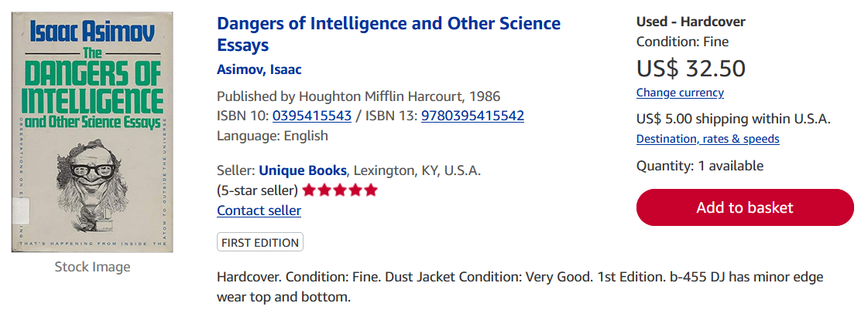
AbeBooks
Short science essays written for American Way, the in-flight magazine for American Airlines. First edition (first printing). A fine copy in a very good dust jacket; wear at the spine head and original price on flap crossed out and different price handwritten

